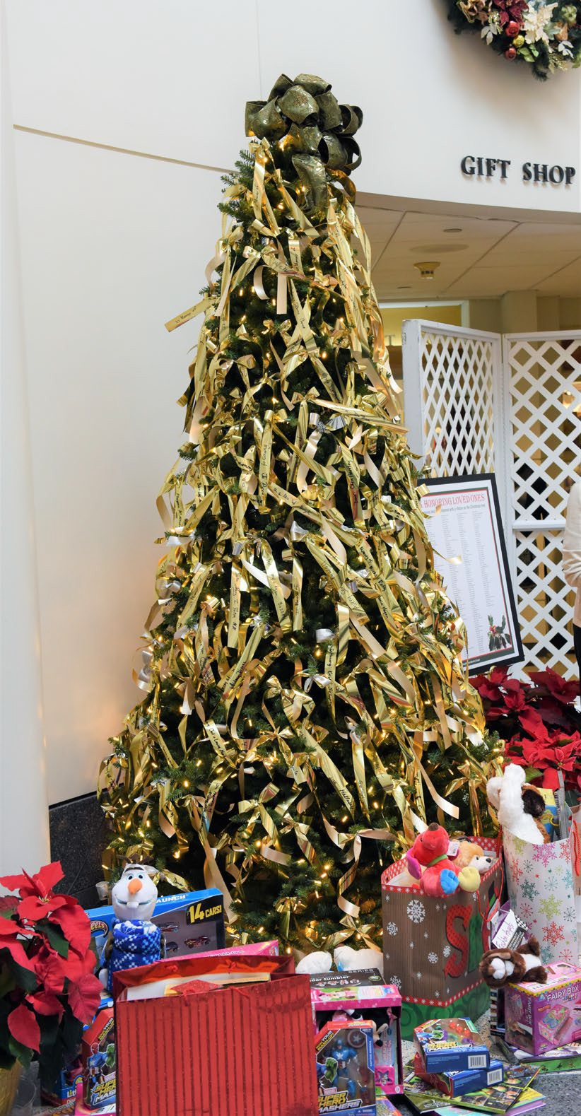
Dear Friends,

This joyous time of year provides you a festive opportunity to honor a loved one or friend—or cherish a loved one's memory—by continuing to make them a part of your holiday season on a special ribbon. Especially this year, when we will be unable to gather together as in years past, honoring or remembering a loved one or a friend in this way is so special.

We will inscribe their name(s) on special ribbons that will be placed on one of our Christmas trees in the Rotunda of Saint Francis Hospital. During a holiday season that will have its own unique challenges, please help us continue this wonderful tradition and make this year's Christmas tree a most decorated one.

All you need to do is fill out the form at the bottom of this letter and return it to us with your request or conveniently pay online or pay at the Auxiliary Gift Shop. We will inscribe your message on a personalized ribbon and place it on the tree for you.

-----
CHRISTMAS HONOR AND MEMORIAL RIBBONS
Ribbons in honor or memory of a friend, relative or a loved one can be purchased with a
$5 donation per ribbon. Complete the form, pay online, pay at the Auxiliary Gift Shop or enclose cash or a check made payable to: The Auxiliary of Saint Francis Hospital. To pay on line, visit www.trinityhealthofne.org/auxiliary and click on write a note (optional) to include names for ribbons or please return this form by December 18, 2020 to:

The Auxiliary
Saint Francis Hospital
114 Woodland Street, Hartford, CT 06105 Attn: Christmas Ribbons
(860) 714-4558

PLEASE PRINT

IN HONOR OF:

IN MEMORY OF:

Donor Name: Telephone:

Email: Amount Enclosed: $

